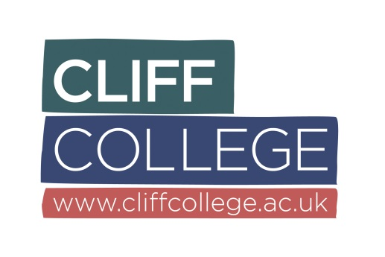
JOB DESCRIPTION
Job Title: Chef
Location: Cliff College, Calver, Hope Valley, Derbyshire S32 3XG
Responsible to: Catering Manager
Internal relationships: Conference Centre Manager, Site & Estates Manager, Receptionist
External relationships: Customers, Suppliers

Purpose and Objectives: To provide customers with high quality food which adheres to the required Gross Profit target for that establishment

Main Responsibilities
- Food Standards
- Plan menus for all service areas
- Ensure all menus comply with the Gross Profit target relevant to the College budget or agreed function costs
- Prepare food with the assistance of subordinate staff to be ready for all service times whilst ensuring that there is a regular replenishment strategy for the whole service period.
- Prepare for College special events and fundraising activities relating to the catering operation
- Finance and Administration
- Complete all food costing as required by the manager ensuring that the correct ingredients prices are used and review these on an agreed basis
- Complete all wastage control sheets for the food prepared
- Count all stock for the designated responsibility area as requested by the Catering Manager
- Put forward suggestions to the Catering Manager for changes to the menu based on any changed to ingredient prices
- Order food items within the areas of responsibility ensuring that the agreed maximum stock levels are adhered to and that the delivery schedule meets the date required.
- Assist the Catering Manager with the completion of financial controls
- Work as Team
- Assist with the training, support and development of new and existing employees as requested
- Fully support the catering team, Catering Manager and College including being flexible in the type of duties undertaken
- Hygiene, Health and Safety
- Prepare food in line with current Food Hygiene and Health & Safety Procedures
- Ensure that all food prepared and served is labelled correctly
- Undertake temperature probing as required and ensure that all records are maintained
- Comply with company and client procedures relating to health, safety and hygiene
- Undertake cleaning duties as designated by the catering manager and the cleaning roster
- Ensure that all equipment is used correctly and cleaned using the correct procedures
- Report any accidents or near misses to the manager and ensure that the information is recorded correctly
- Ensure that all food is used in the correct stock rotation and any out of date items brought to the attention of managers
- College procedures
- To ensure that all staff wear their uniform as provided
- To complete any other reasonable duties, as required by your line manager

TERMS AND CONDITIONS
Terms of appointment Permanent
Hours of Work: 37.5 hours per week, worked over 5 days, plus 30 minutes unpaid lunch break
Remuneration: £9.82 per hour
Health and Safety The post holder will be subject to Cliff College’s Health and Safety policy
Equal Opportunities The post holder will be subject to Cliff College’s Equality, Diversity & Inclusion policy
Physical Conditions Cliff College kitchens
Work Permit: Appointment will be subject to documentary evidence of the right to live and work in the UK
Holiday Entitlement: Your pro rata holiday entitlement is dependent on your years of service:
Years 1-4: 25 days annual leave + 8 bank holidays = 33 days;
Years 5-9: 28 days annual leave + 8 bank holidays = 36 days;
Year 10 onwards: 30 days annual leave + 8 bank holidays = 38 days.
All Cliff College staff are required to work the second May bank holiday as this is Cliff Festival
Sick Pay: Entitlement in accordance with Cliff College’s leave policy
Pension: There is a contributory final salary pension scheme to which eligible lay employees will be auto-enrolled. Employees who do not meet the auto enrolment criteria are eligible to join the Scheme subject to certain provisions
Probationary Period: Appointments for lay employees are made subject to the satisfactory completion of a probationary period, normally three months

