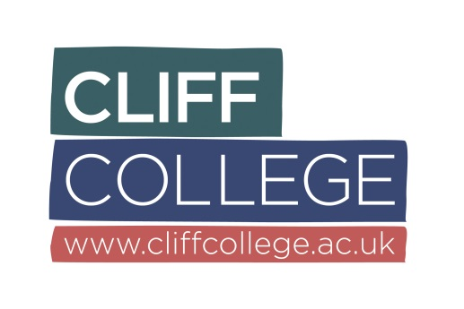
Cliff Year Application Form | Confidential
Please complete this application in black type and provide information for each section of the form. Thank you.

1. Personal Details
Title
Surname (Block letters)

First names
Address (Block letters)
Telephone number | Home
 | Daytime
 | Mobile
E-mail address
Date of birth |  |  | Age on 1 September 2019
Church currently attending
Where did you hear about ‘The Cliff Year’?

Information for applicants
Please read this information carefully before you complete the next part of the form.
- We are inviting you to give us information that will allow us to help you discern whether this is an appropriate opportunity for you. You will need to draw on all aspects of your life, for example, education, employment, voluntary work, church, interests, and home life in order to complete this form.
- Do not think you have to fill in all the space below each question. You may find you wish to answer one question more fully than another.
- We require 3 references. One of these must by your minister/church leader, one must be from a member of your family /close friend and the other from someone you have worked with at work, voluntarily or education.

2. Why are you applying for the Cliff Year?

3. What do you enjoy doing? (We would love to know your favourite things to do this could include your hobbies, sports, creativity as well as roles you have undertaken at work or volunteering).

4. Desert Island Discs question! Imagine you are cast away on a desert island! You are allowed to have 3 items with you, please tell us what you would bring with you from the categories below.
- You are allowed to select a book to take with you (you are automatically given a copy of the bible and the Complete Works of Shakespeare). What third book would you take to accompany you?
- You may choose one luxury item. This must be an inanimate object and of no use in escaping the island or allowing communication from outside.
- Speakers on the island will play you one song (the same song) every day. What song would you choose that to be?

5. Briefly state your Christian story. (This should include who Jesus is to you and your present relationship with God).

6. Please tell us about the church you currently attend. What is it like and if you could change anything about it what would that be?

7. Please tell us about one person who has influenced you in your life and how.

8. Education and Training
Please list your qualifications, including any you are due to complete before September 2019.
Qualification | Date Obtained | Grade

9. Employment & Volunteer Roles
This should include any paid or voluntary roles you have undertaken and may include roles at church.
Name/address of organisation | Position held | From/to | Reason for stopping

10. References
Please give the names, postal & email addresses, and telephone numbers of three referees who can broadly represent your church and personal interests.
- minister/church leader
Name
Position
Church name and address
Email
Telephone
- member of your family /close friend
Name
Relationship to you
Address
Email
Telephone
- someone you have worked with at work, voluntarily or during your education
Name
Position
Organisation name and address
Email
Telephone

Disability:
The Equality Act 2010 defines disability as "a physical or mental impairment which has a substantial & long term effect on a person’s ability to carry out normal day to day activities".
Do you consider yourself to have a disability? | Yes | No | Prefer not to say
If Yes, please advise of any reasonable adjustments you require for the purposes of the recruitment exercise below:

11. Some final questions that would be helpful for us to know.

Do you hold a UK driver’s license? | Yes No | Full Provisional
Do you own a car? | Yes No
As part of the Cliff Year we require a Satisfactory DBS to be completed as during the year you may be working with children, young people and vulnerable adults.

Do you have any Criminal Convictions not “spent” under the Rehabilitation of Offenders Act 1974?

Yes No
If Yes, please supply further details below:

Thank you for completing this application form.

Please email your completed form to Tom Donoghue, cliffyear@cliffcollege.ac.uk
Cliff College, Calver, Hope Valley, Derbyshire S32 3XG

